**Relevant screenshots of chatbot**

**Amazon LEX**

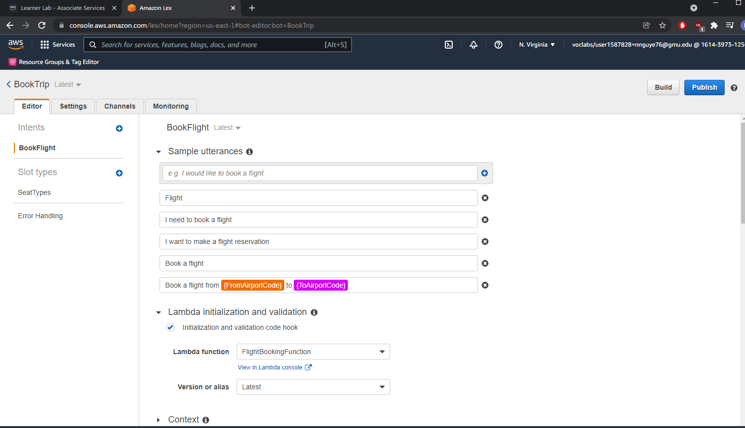

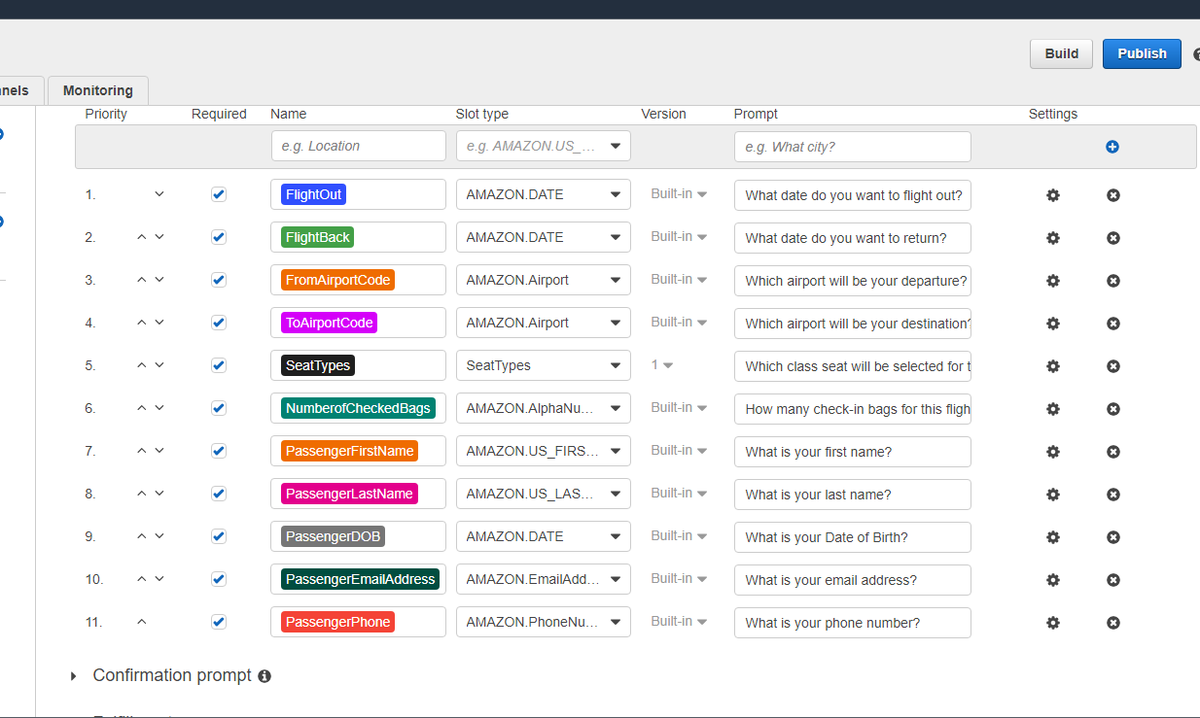

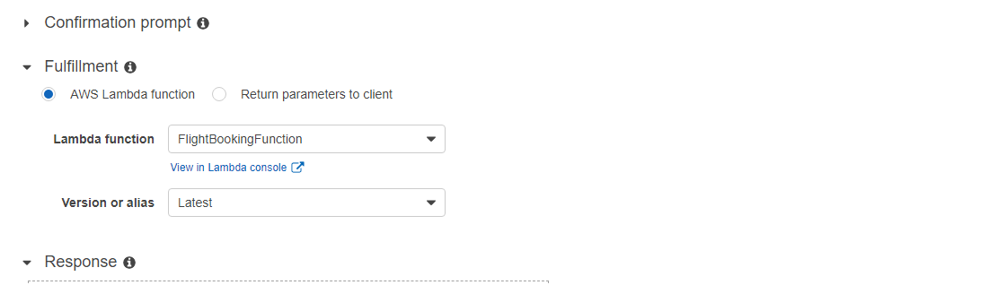

**Test Chatbot Sample:**

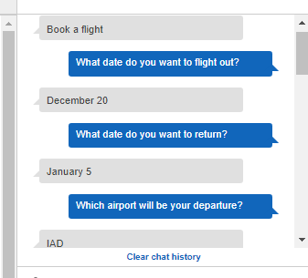 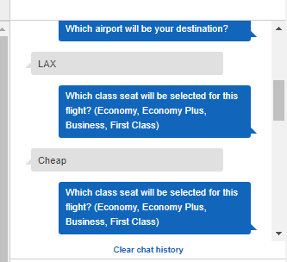

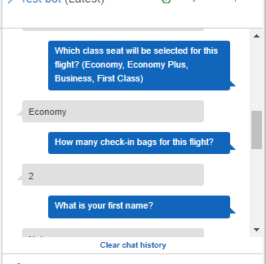 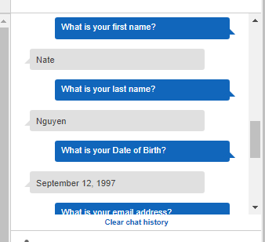

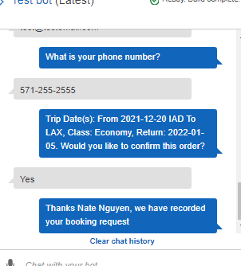 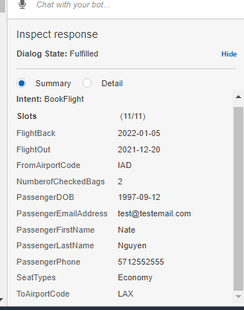

**DynamoDB table Content**

**Table:**

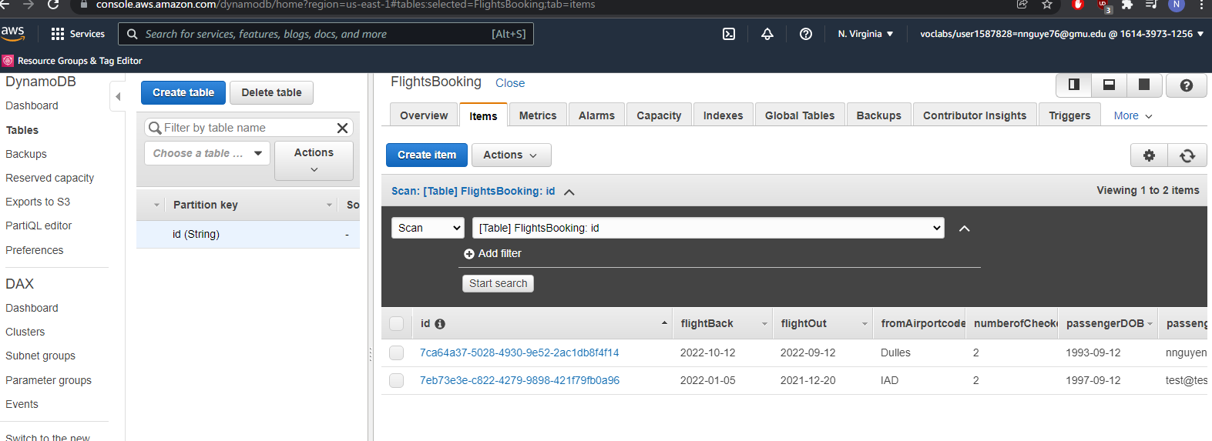

**Data:** 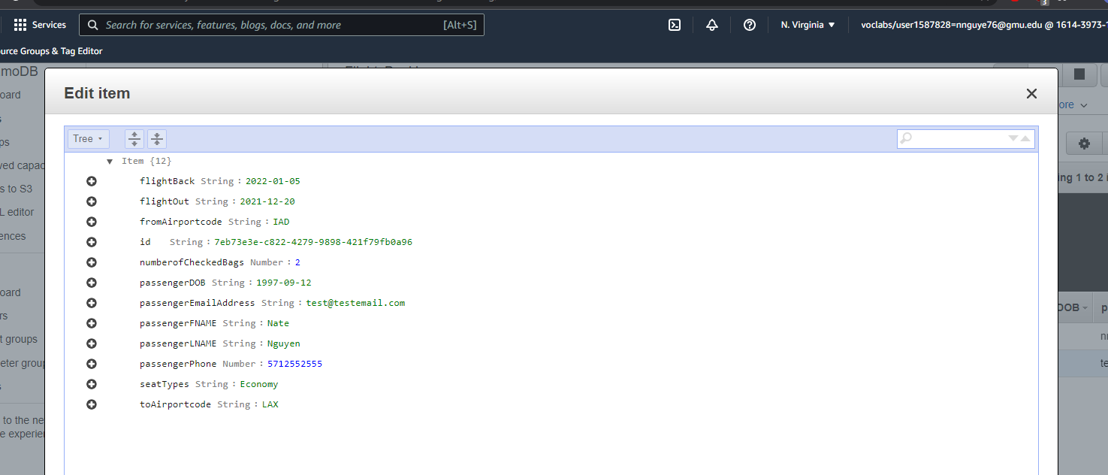

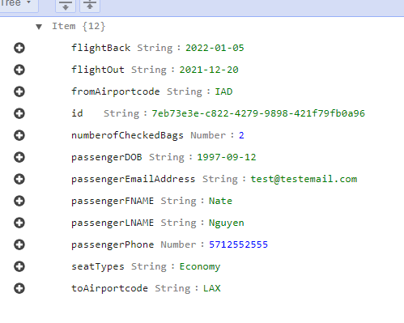

**List S3 Bucket**

**Bucket:**

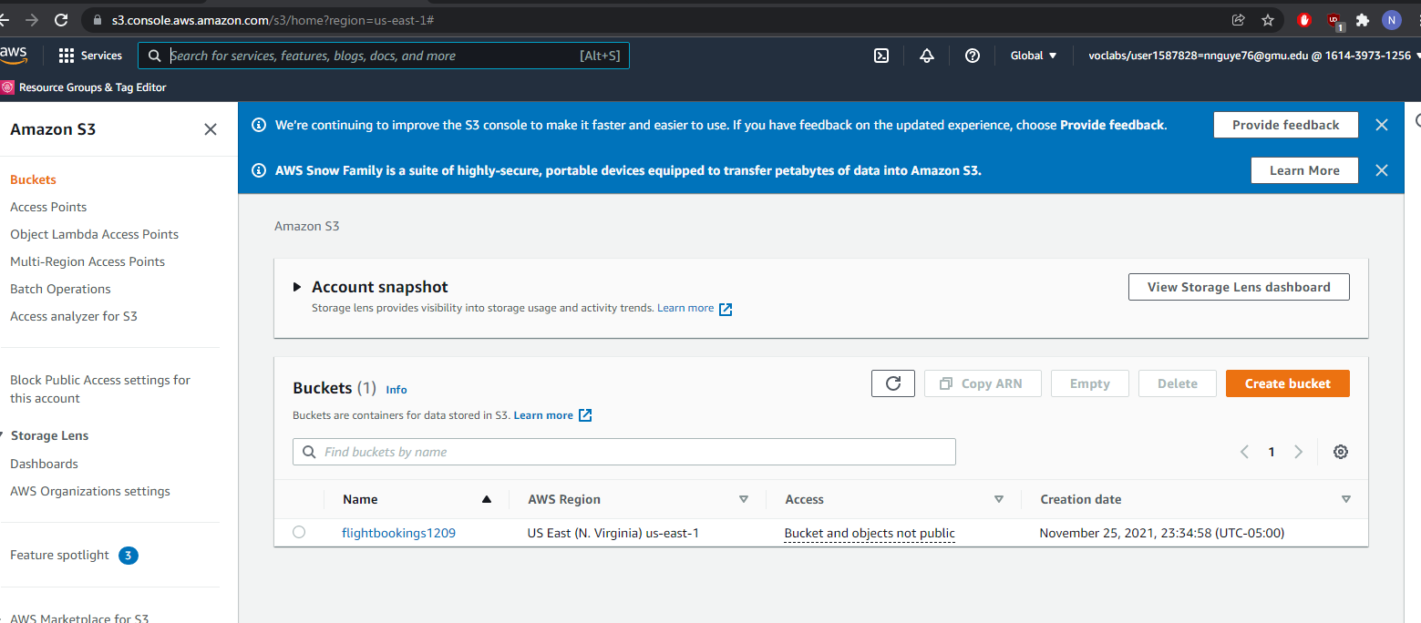

**Upload Text File to Bucket:**

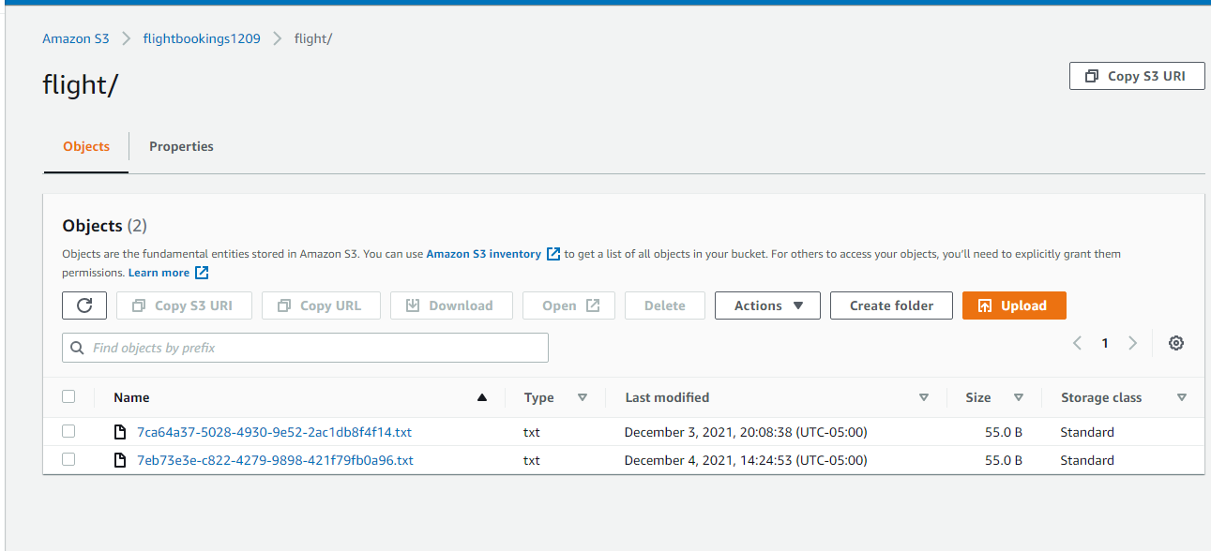

**Lambda Function Code**

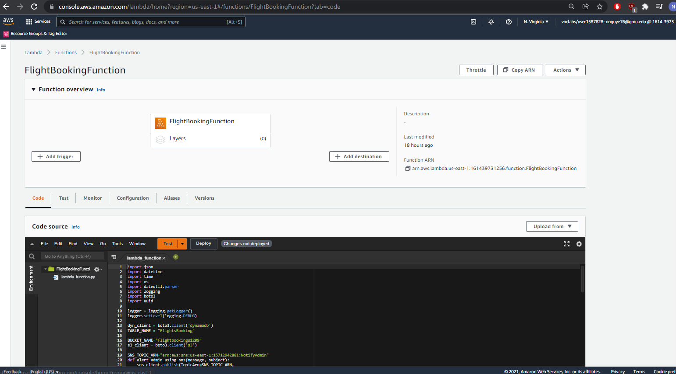

**Code:**

**import json**

**import datetime**

**import time**

**import os**

**import dateutil.parser**

**import logging**

**import boto3**

**import uuid**

**logger = logging.getLogger()**

**logger.setLevel(logging.DEBUG)**

**dyn_client = boto3.client('dynamodb')**

**TABLE_NAME = "FlightsBooking"**

**BUCKET_NAME="flightbookings1209"**

**s3_client = boto3.client('s3')**

**SNS_TOPIC_ARN="arn:aws:sns:us-east-1:15712942881:NotifyAdmin"**

**def alert_admin_using_sns(message, subject):**

**sns_client.publish(TopicArn=SNS_TOPIC_ARN,**

**Message=message,**

**Subject=subject)**

**def store_details_to_s3(bucket, key, data):**

**s3_client.put_object(Body=data, Bucket=bucket, Key=key)**

**def dispatch(intent_request):**

**logger.debug('dispatch userId={}, intentName={}'.format(intent_request['userId'], intent_request['currentIntent']['name']))**

**intent_name = intent_request['currentIntent']['name']**

**if intent_name == 'BookFlight':**

**return take_flightbooking(intent_request)**

**raise Exception('Intent with name ' + intent_name + ' not supported')**

**def lambda_handler(event, context):**

**os.environ['TZ'] = 'America/New_York'**

**time.tzset()**

**logger.debug('event.bot.name={}'.format(event['bot']['name']))**

**return dispatch(event)**

**# --- Helper Functions ---**

**def safe_int(n):**

**"""**

**Safely convert n value to int.**

**"""**

**if n is not None:**

**return int(n)**

**return n**

**def try_ex(func):**

**"""**

**Call passed in function in try block. If KeyError is encountered return None.**

**This function is intended to be used to safely access dictionary.**

**Note that this function would have negative impact on performance.**

**"""**

**try:**

**return func()**

**except KeyError:**

**return None**

**def elicit_slot(session_attributes, intent_name, slots, slot_to_elicit, message):**

**return {**

**'sessionAttributes': session_attributes,**

**'dialogAction': {**

**'type': 'ElicitSlot',**

**'intentName': intent_name,**

**'slots': slots,**

**'slotToElicit': slot_to_elicit,**

**'message': message**

**}**

**}**

**def confirm_intent(session_attributes, intent_name, slots, message):**

**return {**

**'sessionAttributes': session_attributes,**

**'dialogAction': {**

**'type': 'ConfirmIntent',**

**'intentName': intent_name,**

**'slots': slots,**

**'message': message**

**}**

**}**

**def close(session_attributes, fulfillment_state, message):**

**response = {**

**'sessionAttributes': session_attributes,**

**'dialogAction': {**

**'type': 'Close',**

**'fulfillmentState': fulfillment_state,**

**'message': message**

**}**

**}**

**return response**

**def delegate(session_attributes, slots):**

**return {**

**'sessionAttributes': session_attributes,**

**'dialogAction': {**

**'type': 'Delegate',**

**'slots': slots**

**}**

**}**

**#-- DynamoDB Save**

**def save_flight(flightOut, flightBack, fromAirportcode, toAirportcode, seatTypes, numberofCheckedBags, passengerFNAME, passengerLNAME, passengerDOB, passengerEmailAddress, passengerPhone):**

**id = str(uuid.uuid4())**

**flightBookings = json.dumps({**

**'flightOut': flightOut,**

**'flightBack': flightBack,**

**'fromAirportcode': fromAirportcode,**

**'toAirportcode': toAirportcode,**

**'seatTypes': seatTypes,**

**'numberofCheckedBags': numberofCheckedBags,**

**'passengerFNAME': passengerFNAME,**

**'passengerLNAME': passengerLNAME,**

**'passengerDOB': passengerDOB,**

**'passengerEmailAddress': passengerEmailAddress,**

**'passengerPhone': str(passengerPhone),**

**})**

**data = dyn_client.put_item(**

**TableName=TABLE_NAME,**

**Item={**

**'id': {**

**'S': id**

**},**

**'flightOut': {**

**'S': flightOut**

**},**

**'flightBack': {**

**'S': flightBack**

**},**

**'fromAirportcode': {**

**'S': fromAirportcode**

**},**

**'toAirportcode': {**

**'S': toAirportcode**

**},**

**'seatTypes': {**

**'S': seatTypes**

**},**

**'numberofCheckedBags': {**

**'N': numberofCheckedBags**

**},**

**'passengerFNAME': {**

**'S': passengerFNAME**

**},**

**'passengerLNAME': {**

**'S': passengerLNAME**

**},**

**'passengerDOB': {**

**'S': passengerDOB**

**},**

**'passengerEmailAddress': {**

**'S': passengerEmailAddress**

**},**

**'passengerPhone': {**

**'N': str(passengerPhone)**

**}**

**}**

**)**

**store_details_to_s3(BUCKET_NAME, "flight/{}.txt".format(id), flightBookings)**

**# --- Validation Functions ---**

**def isvalid_seatType(seatType):**

**seatTypes = ['economy', 'economy plus', 'business', 'first class']**

**return seatType.lower() in seatTypes**

**def validate_bookings(slots):**

**flightOut = try_ex(lambda: slots['FlightOut'])**

**flightBack = try_ex(lambda: slots['FlightBack'])**

**fromAirportcode = try_ex(lambda: slots['FromAirportCode'])**

**toAirportcode = try_ex(lambda: slots['ToAirportCode'])**

**seatType = try_ex(lambda: slots['SeatTypes'])**

**numberofCheckedBags = safe_int(try_ex(lambda: slots['NumberCheckedBags']))**

**passengerFNAME = try_ex(lambda: slots['PassengerFirstName'])**

**passengerLNAME = try_ex(lambda: slots['PassengerLastName'])**

**passengerDOB = try_ex(lambda: slots['PassengerDOB'])**

**passengerEmailAddress = try_ex(lambda: slots['PassengerEmailAddress'])**

**passengerPhone = try_ex(lambda: slots['PassengerPhone'])**

**if seatType and not isvalid_seatType(seatType):**

**return build_validation_result(**

**False,**

**'SeatTypes',**

**'I did not recognize that Class Seat type. Which class seat will be selected for this flight? (Economy, Economy Plus, Business, First) '**

**)**

**return {'isValid': True}**

**def build_validation_result(isvalid, violated_slot, message_content):**

**return {**

**'isValid': isvalid,**

**'violatedSlot': violated_slot,**

**'message': {'contentType': 'PlainText', 'content': message_content}**

**}**

**def take_flightbooking(intent_request):**

**slots = intent_request['currentIntent']['slots']**

**flightOut = slots['FlightOut']**

**flightBack = slots['FlightBack']**

**fromAirportcode = slots['FromAirportCode']**

**toAirportcode = slots['ToAirportCode']**

**seatType = slots['SeatTypes']**

**numberofCheckedBags = slots['NumberofCheckedBags']**

**passengerFNAME = slots['PassengerFirstName']**

**passengerLNAME = slots['PassengerLastName']**

**passengerDOB = slots['PassengerDOB']**

**passengerEmailAddress = slots['PassengerEmailAddress']**

**passengerPhone = slots['PassengerPhone']**

**session_attributes = intent_request['sessionAttributes'] if intent_request['sessionAttributes'] is not None else {}**

**logger.debug(intent_request['invocationSource'])**

**if intent_request['invocationSource'] == 'DialogCodeHook':**

**validation_result = validate_bookings(intent_request['currentIntent']['slots'])**

**logger.debug(validation_result)**

**if not validation_result['isValid']:**

**slots[validation_result['violatedSlot']] = None**

**return elicit_slot(**

**session_attributes,**

**intent_request['currentIntent']['name'],**

**slots,**

**validation_result['violatedSlot'],**

**validation_result['message']**

**)**

**return delegate(session_attributes, intent_request['currentIntent']['slots'])**

**save_flight(flightOut, flightBack, fromAirportcode, toAirportcode, seatType, numberofCheckedBags, passengerFNAME, passengerLNAME, passengerDOB, passengerEmailAddress, passengerPhone)**

**return close(**

**session_attributes,**

**'Fulfilled',**

**{**

**'contentType': 'PlainText',**

**'content': 'Thanks {} {}, we have recorded your booking request'.format(passengerFNAME, passengerLNAME)**

**}**

**)**

**Trip Text File**

**File:**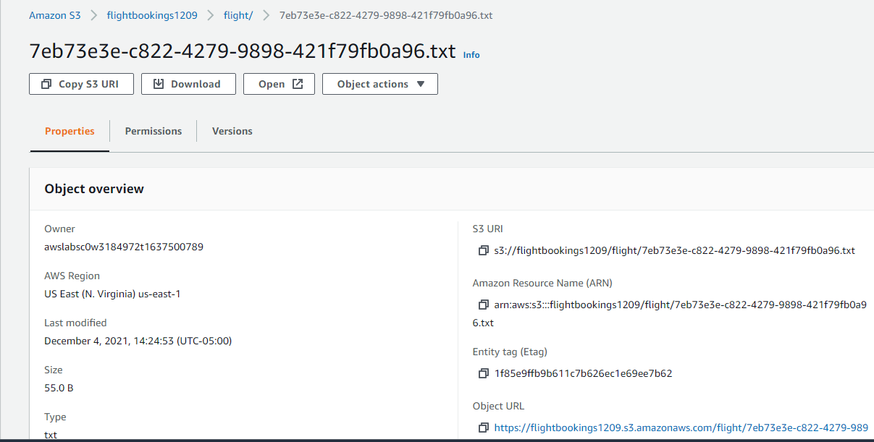

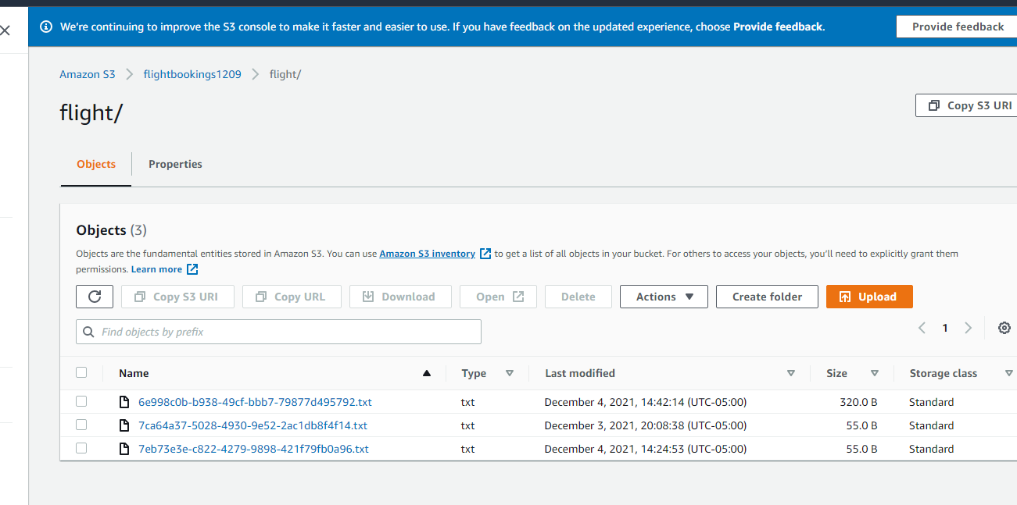

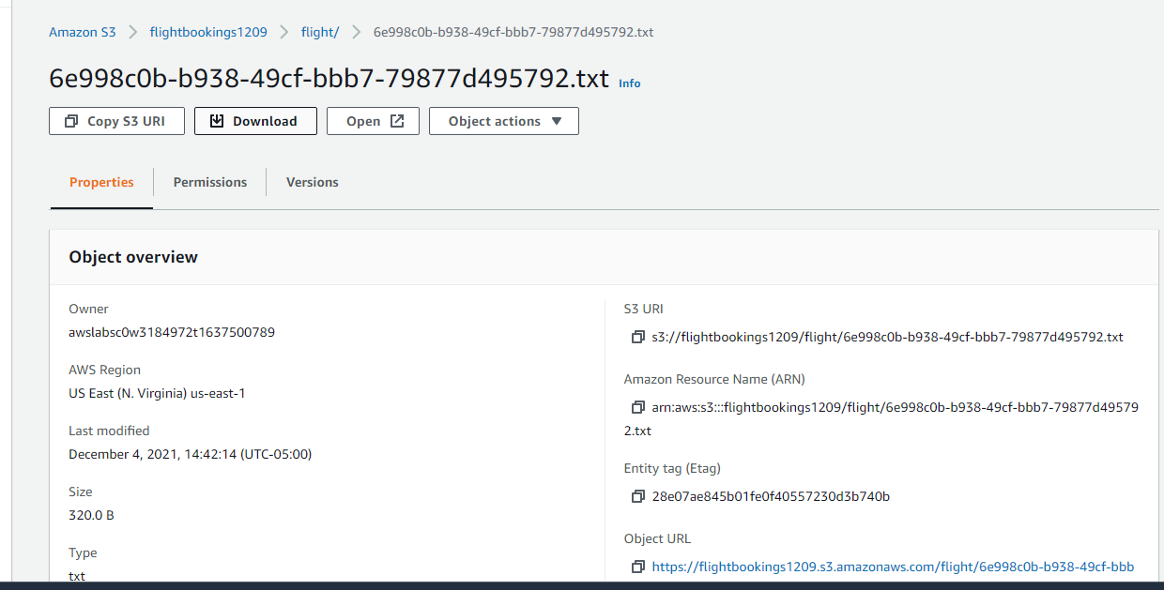

**TXT File:**



**{"flightOut": "2021-12-20", "flightBack": "2022-01-05", "fromAirportcode": "IAD", "toAirportcode": "LAX", "seatTypes": "Economy", "numberofCheckedBags": "2", "passengerFNAME": "Nate", "passengerLNAME": "Nguyen", "passengerDOB": "1997-09-12", "passengerEmailAddress": "test@testemail.com", "passengerPhone": "5712552555"}**